DML Commands
Inserting the values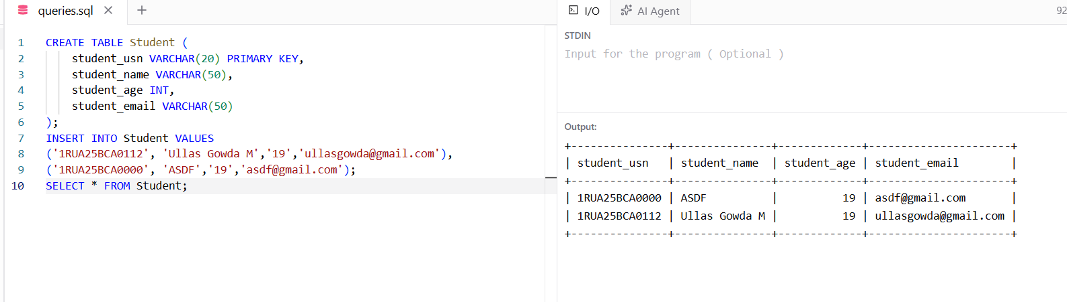

Updating the Value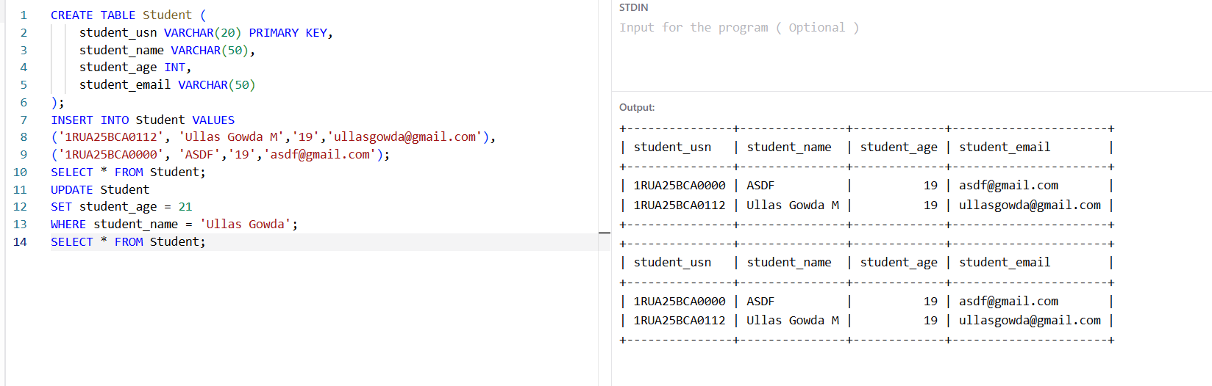

Deleting the Value


